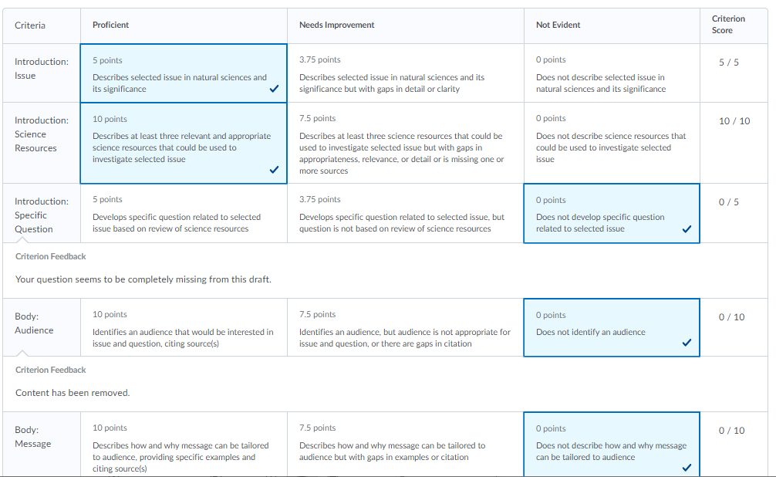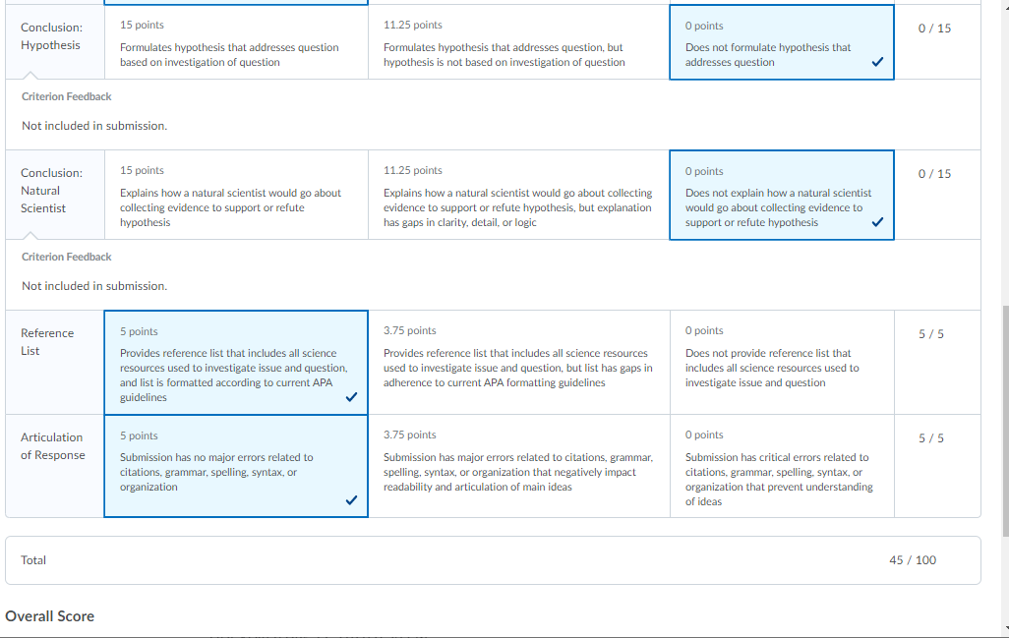
Feedback
22.5 / 50

F

Megan,
I appreciate you getting this submitted, but I'm a little confused by this draft. You've removed much of the required elements that were in your first draft, removed all of your headings, and didn't add the two new requirements for this second draft (a hypothesis and description of an experiment). I'd highly recommend you trying this again. Please let me know what questions you have and how I can help you better understand the requirements of the assignment. I'm here to help!
Take care,
Christina
less
Last Modified Sunday, August 16, 2020 12:38 PM EDT

